**Add and update bookings**

**Scenario**

They need you to create stored procedures that they can invoke as required to add, update and delete bookings in their database

**Task 1**

**Create a new procedure called AddBooking to add a new table booking record.**The procedure should include four input parameters in the form of the following bookings parameters:**booking id, customer id,**

**booking date,and table number.**

**Solution of Task 1: AddBooking Procedure**

DELIMITER $$

CREATE PROCEDURE AddBooking(

IN booking_id INT,

IN customer_id INT,

IN booking_date DATE,

IN table_number INT,

OUT confirmation VARCHAR(255)

)

BEGIN

INSERT INTO bookings (BookingID, CustomerID, BookingDate, TableNumber)

VALUES

(booking_id, customer_id, booking_date, table_number);

SET confirmation = 'New booking added';

END $$

DELIMITER ;

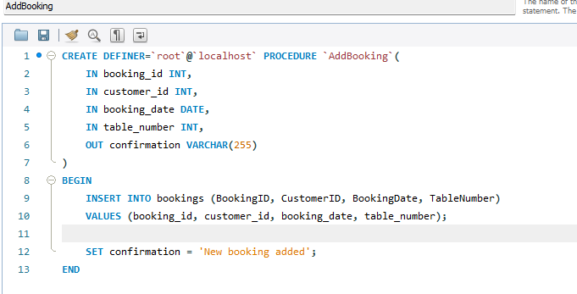

**CALL AddBooking(9, 3, '2022-12-30', 4, @confirmation);**

**SELECT @confirmation AS confirmation;**

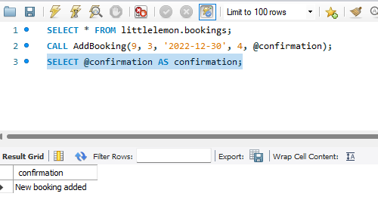

**Solution of Task 2: UpdateBooking Procedure**

DELIMITER //

CREATE PROCEDURE UpdateBooking(

IN booking_id INT,

IN booking_date DATE,

OUT confirmation VARCHAR(255)

)

BEGIN

UPDATE bookings

SET booking_date = booking_date

WHERE booking_id = booking_id;

SET confirmation = CONCAT('Booking ', booking_id, ' updated');

END //

DELIMITER ;

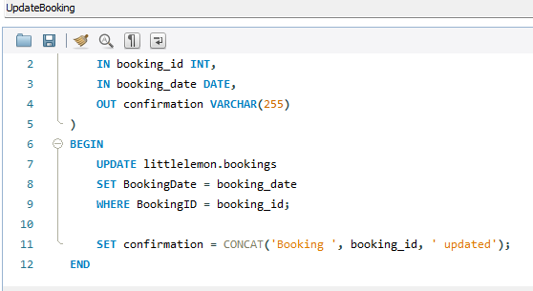

CALL UpdateBooking(9, '2022-12-17', @confirmation);

SELECT @confirmation AS confirmation;

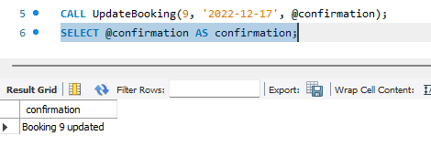

**-- Task 3: CancelBooking Procedure**

DELIMITER $$

CREATE PROCEDURE CancelBooking(

IN booking_id INT,

OUT confirmation VARCHAR(255)

)

BEGIN

DELETE FROM bookings

WHERE booking_id = booking_id;

SET confirmation = CONCAT('Booking ', booking_id, ' cancelled');

END $$

DELIMITER ;

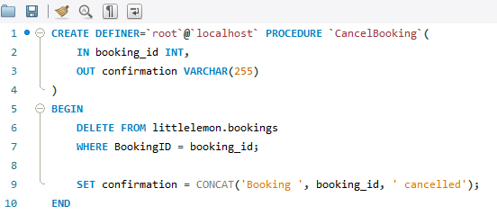

**CALL CancelBooking(9, @confirmation);**

**SELECT @confirmation AS confirmation;**

